POTENTIAL BULLYING INCIDENT - REPORT FORM
(Learners only – for staff refer to Sense HR Policies and Procedures)

Name of the possible VICTIM – the person who may have been bullied | Day & Date of incident | Service
 |  | ESFA ☐ ELP ☐
Name & Role of person making this report | Name of Centre

Where did the incident take place? | ☐ Sense Centre | ☐ In the Community | ☐ Other  _____________
Name of the ALLEGED PERPETRATOR – the person who may have demonstrated bullying/inappropriate behaviour towards another
How was the incident disclosed?

Please provide brief details relating to the incident / reasons for potential bullying concern:
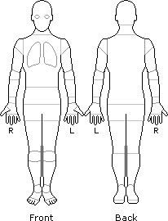
Lo
cation

of
Any Injury/Physical contact
–

(
Please circle or tick any areas affected
, if appropriate):

Did this bullying incident result in an accident form being completed? | ☐ Yes | ☐ No | If yes – please note System entry reference here:
Did this bullying incident result in a behaviour form being completed? | ☐ Yes | ☐ No | If yes – please note System entry reference here:

Please record the thoughts/wishes of the individual who has been bullied.
What would they like to see happen? How has this information been gathered?

Incident Referred to: | ☐ EC/AC | ☐ ESM | ☐ Designated SfG Lead/SMT

Action Taken:

Deputy Designated Person’s Comments:

Follow up Information or
Outcomes

Please record how the named individual has been involved in resolving this.
Administration Use Only | ☐ ESFA Learners Only Entered on Databridge System | ☐ Referred to Safeguarding

NB – Sense College recognises that bullying can occur between colleagues in the workplace. Bullying is against the values that Sense upholds. If you feel you have been the victim of bullying in the workplace, please refer to the relevant HR policies and guidance, available on Engage, or speak to your line manager.

