Sense College Loughborough

Careers Guidance Policy

Contents

Introduction page 3
Scope and context page 3
Aims page 3
Objectives page 3
Associated college documents page 4
External partners supporting our careers guidance offer page 4
National documents influencing our careers guidance offer page 5
Monitoring and quality assurance of our careers provision page 5
Key staff involved in our careers guidance provision page 5
Review procedure page 6

Appendix A: College Careers Offer page 7
Appendix B: Gatsby benchmarks

Introduction

The purpose of this policy is to ensure that every student has relevant access to high quality careers guidance, allowing them to make informed decisions about their future.
At Sense College Loughborough we think about Careers Guidance in its widest sense. It is all about activity which supports our students when they leave college.
In this policy we will refer to Careers Guidance as the full range of activity delivered under the eight Gatsby Benchmarks. We work towards meeting the Gatsby Benchmarks (Appendix B) as this helps us to ensure we are covering all areas of good careers guidance.
We have a careers offer diagram (Appendix A) which shows the different elements that make up our careers guidance programme.

Scope and context

This policy and our careers offer has been reviewed in line with Department of Education guidance ‘Careers Guidance and access for education and training providers - statutory guidance for schools and guidance for further education colleges and sixth form colleges.’
This policy recognises the Gatsby benchmarks as the underpinning elements of good careers guidance.
We offer different educational pathways, and work with Loughborough College, so our students gain the skills, knowledge, behaviours and experiences to achieve their goals. Our careers offer diagram (Appendix A) shows the different elements that make up our careers guidance programme. This will look different across each of our different education pathways as we will tailor the provision to ensure it is relevant and appropriate.

Aims

Our careers programme aims to prepare students to achieve their long term goals and prepare them for life after college. This may be to get a job, voluntary work or get more involved in their local community. We support our students to be as independent as possible, and from the moment our students start at college, everything we do will be working to make this happen.

Objectives

The objectives of the Careers Education, Information, Advice and Guidance policy are as follows:
- To ensure there is a programme of careers guidance which is reviewed, evaluated and available for students, parents/carers, governors and employers to see.
- To provide our students (and where relevant their families) with information to help them make informed choices about their next steps (Labour Market Information, known as LMI)
- To provide careers guidance that is individual and addresses the needs of each student
- To ensure our curriculum learning is linked to our students next steps
- To provide students with relevant encounters and experiences of organisations and individuals linked to their potential next steps (this could be work experience, visits to Further Education colleges, talks from past students, social care providers, or services our students will encounter when they finish college)
- To provide each student with the opportunity to receive personal guidance

Associated college documents

- Provider Access Legislation (PAL) policy
- Careers Offer/Careers programme document

External partners supporting our careers guidance offer
We work with a number of organisations externally to support our CEIAG, this includes:
- Leicester and Leicestershire Enterprise Partnership (LLEP)
- Leicestershire Education Business Company (LEBC) Personal Advisor for our IAG sessions
- Department for Work and Pensions (DWP) local Schools/College Advisor
- Pathways (a widening participation partnership project delivered by some of the Higher Education and Further Education providers across Leicester and Leicestershire and Rutland) have delivered a project to some of our students considering FE.
In addition the college also has a number of local organisations who support us with work placements and other employer interactions for our students.

National documents influencing our careers guidance offer

All Further Education (FE) colleges have been required to secure access to independent careers guidance since September 2013. This requirement is part of FE college funding agreements. Careers guidance and access for education and training providers - Statutory guidance for schools and guidance for further education colleges and sixth form colleges (January 2023)
- The Gatsby Benchmarks for good careers guidance
- The Matrix Standard, International quality standard for organisations that deliver information, advice and/or guidance (IAG)
- Provider Access Legislation (please see our Provider Access Legislation statement on our website)

Monitoring and quality assuring our Careers Education Information, Advice and Guidance (CEIAG) provision

- Compass results
- Matrix accreditation and annual continuous improvement checks
- Staff self-assessment
- Student voice feedback
- Surveys with stakeholders (parent/carer, student, employer, staff survey)
- Destinations data
- Case studies
- Annual follow up calls with leavers
- Work placement survey
- Surveys before and after an activity
- Reports to our governors
- Students targets and target achievement

Key staff involved in our careers guidance provision

- Gina Hufford, Employment Coordinator (Registered Careers Leader) responsible for coordinating the college employability programme and employer engagement activity. Gina is a member of the Career Development Institute (CDI)
- Simone Allen, Transition Coordinator for students on the Vocational pathway
- Debbie Bond, Transition Coordinator for students on the Learning for Life and Creative and Enterprise
- SEND Tutors, supporting students to reach their long term goals through tutorials and their wider programme of their college learning
- Hannah Wharton, Assistant Principal – Admissions, Engagement and Transitions (Senior Management Team responsibility for careers) Hannah is a member of the Career Development Institute (CDI)

Review Procedure

Policy title | Careers Education, Information, Advice and Guidance Policy
Policy scope | Sense College Loughborough
Issue date (m/y) | August 2023 (initially Oct 2008)
Owner | Assistant Principal – Admissions, Engagement and Transitions
Approved by
Distribution | SMT and Team Leaders, added to internet for all stakeholders
Reviewed due | July 2025
Appendixes

Appendix A

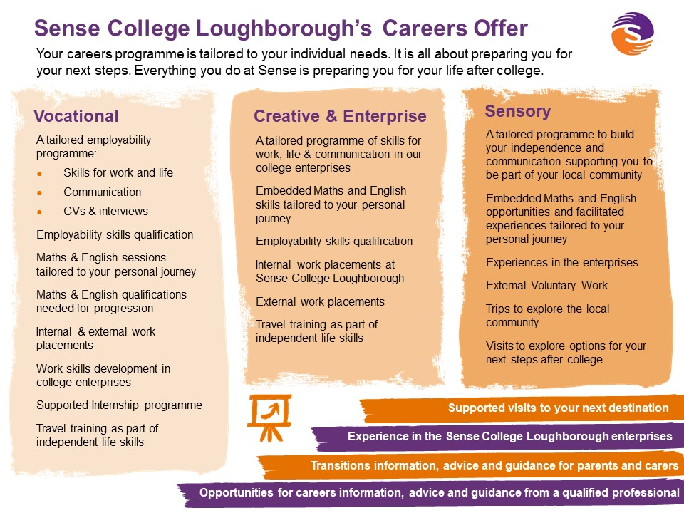

Appendix B

Gatsby Benchmarks and definitions for colleges

Benchmark 1 | A stable careers programme | Every school and college should have an embedded programme of career education and guidance that is known and understood by pupils, parents, teachers and employers.  - Every college should have a stable, structured careers programme that has the explicit backing of the senior management team, and has an identified and appropriately trained person responsible for it.  - The careers programme should be published on the college’s website in a way that enables learners, parents, college staff and employers to access and understand it. The programme should be regularly evaluated, with feedback from learners, parents, college staff and employers as part of the evaluation process.
Benchmark 2 | Learning from career and labour market information | Every learner and their parents/carers (where appropriate) should have access to good quality information about future study options and labour market opportunities. They will need the support of an informed adviser to make best use of available information.  - During their study programme, all learners should access and use information about career paths and the labour market to inform their own decisions on study options.  - Parents should be encouraged to access and use information about labour markets and future study options to inform their support to the learners in their care.
Benchmark 3 | Addressing the needs of each pupil | Learners have different career guidance needs at different stages.  Opportunities for advice and support need to be tailored to the needs of each learner. A college’s careers programme should embed equality and diversity considerations throughout.  - A college’s careers programme should actively seek to challenge stereotypical thinking and raise aspirations.  - Colleges should keep systematic records of the individual advice given to each learner, and subsequent agreed decisions.  - The records of advice given should be integrated with those given at the previous stage of the learner’s education (including their secondary school) where these are made available. Records should begin to be kept from the first point of contact or from the point of transition.  - All learners should have access to these records to support their career development. Colleges should collect and maintain accurate data for each learner on their education, training or employment destinations.
Benchmark 4 | Linking curriculum learning to careers | All subject staff should link curriculum learning with careers, even on courses which are not specifically occupation-led. For example, STEM subject staff should highlight the relevance of STEM subjects for a wide range of future career paths. Study programmes should also reflect the importance of maths and English as a key expectation from employers.  - Throughout their programme of study (and by the end of their course) every learner should have had the opportunity to experience how their subjects help people gain entry to (and be more effective workers within) a wide range of occupations.
Benchmark 5 | Encounters with employers and employees | Every learner should have multiple opportunities to learn from employers about work, employment and the skills that are valued in the workplace. This can be through a range of enrichment activities, including visiting speakers, mentoring and enterprise schemes, and should include learners’ own part-time employment where it exists.  - Every year, alongside their study programme, learners should participate in at least two meaningful encounters* with an employer. At least one encounter should be delivered through their curriculum area.  - Colleges should record and take account of learners’ own part-time employment and the influence this has had on their development.  * A ‘meaningful’ encounter is one in which the student has an opportunity to learn about what work is like or what it takes to be successful in the workplace.
Benchmark 6 | Experiences of workplaces | Every learner should have first-hand experiences of the workplace through work visits, work shadowing and/or work experience to help their exploration of career opportunities, and expand their networks.  - By the end of their study programme, every learner should have had at least one experience of a workplace, additional to any part-time jobs they may have.
Benchmark 7 | Encounters with Further and Higher Education | All pupils/learners should understand the full range of learning opportunities that are available to them. This includes both academic and technical and vocational routes and learning in schools, colleges, universities and in the workplace.  - By the end of their programme of study, every learner should have had a meaningful encounter* with a range of providers of learning and training that may form the next stage of their career. This should include, as appropriate, further education colleges, higher education and apprenticeship and training providers. This should include the opportunity to meet both staff and learners.  * A ‘meaningful’ encounter is one in which the student has an opportunity to explore what it’s like to learn in that environment.
Benchmark 8 | Personal Guidance | Every learner should have opportunities for guidance interviews with a careers adviser, who could be internal (a member of college staff) or external, provided they are trained to an appropriate level.* These should be available for all learners whenever significant study or career choices are being made. They should be expected for all learners, but should be timed to meet individual needs.  - Every learner should have at least one such interview by the end of their study programme.  *The college should ensure that access to a level 6 adviser is available when needed.

